Lab 11 Activities

Submitted by:
Tayyaba Munir
Submitted to :
Ma’am Yasmeen Jana
Registration no :
SP23-BSE-025
Subject :
Advanced Web Technologies



1. Project Overview
ye project JWT-based Authentication system hai jo Node.js, Express, aur MongoDB use karke banaya gaya hai. Iska maqsad user registration, login, aur secure routes ko handle karna hai.

2. Project Structure (Files)
Apne VS Code ke explorer (left side bar) ka screenshot lagayein ya ye list likhein:
- server.js (Main entry point)
- models/user.js (User Schema)
- routes/auth.js (Auth logic)
- routes/protected.js (Protected route)
- middleware/auth.js (JWT Verification)
- .env (Environment variables)

3. Core Code Snippets

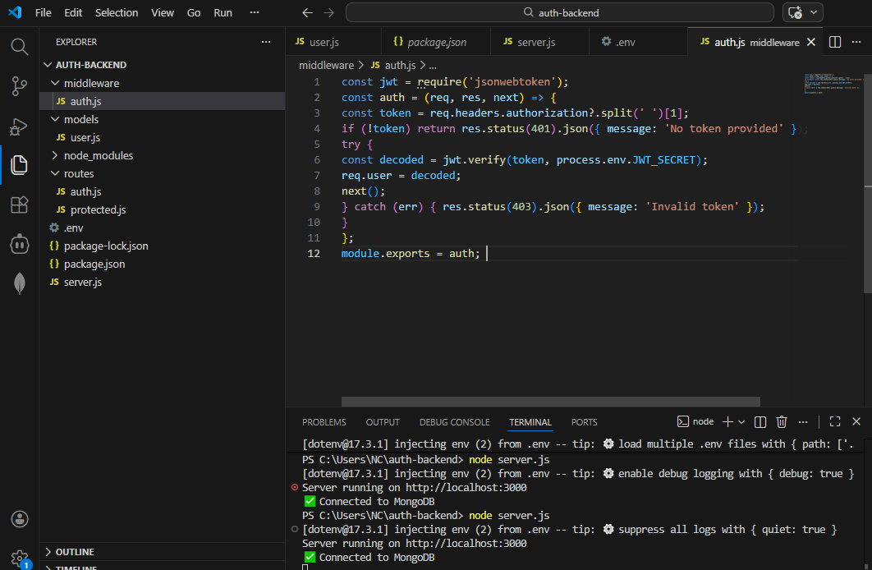

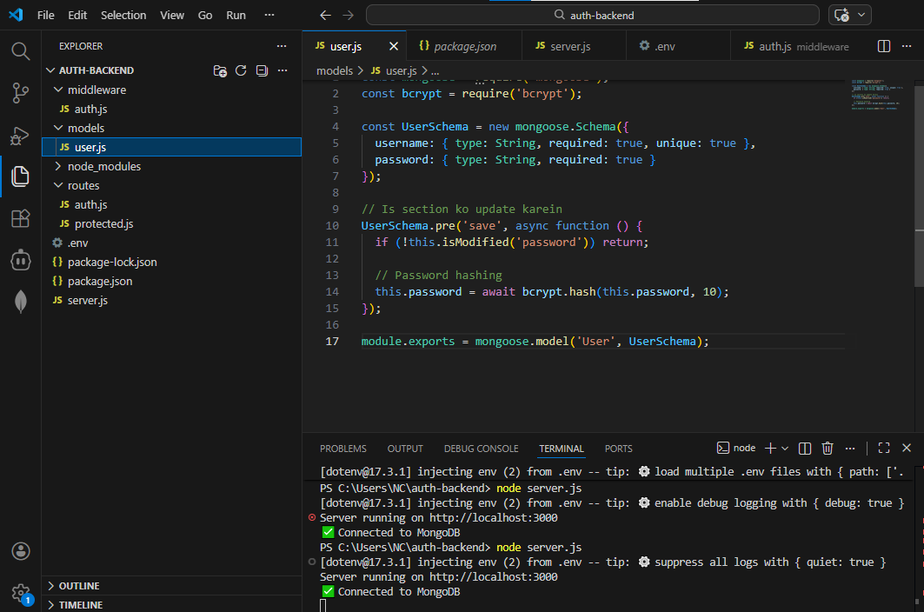

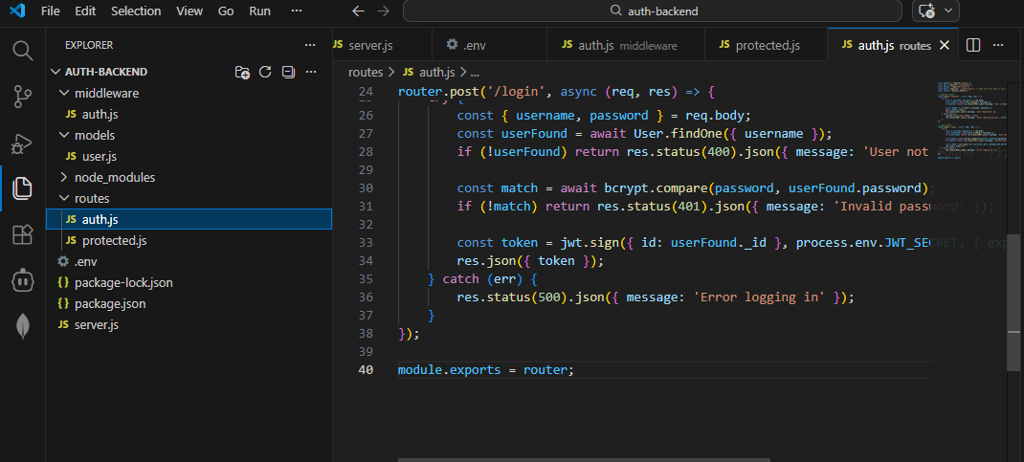

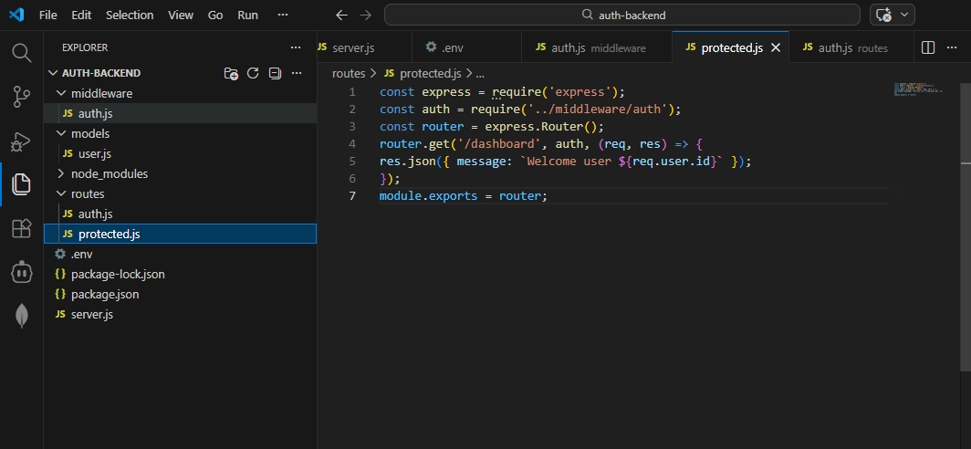

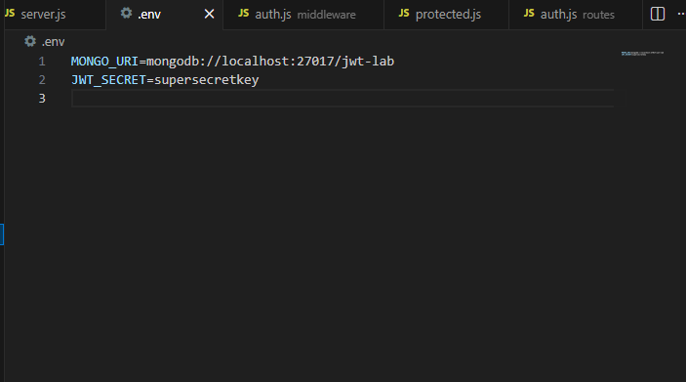

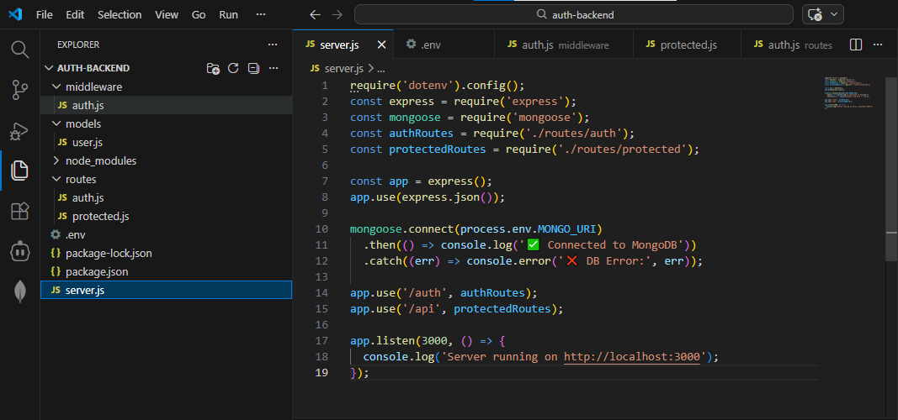

4. Successful Test Results (Postman Screenshots)

Activity | Postman URL | Expected Output (Screenshot)
User Registration | POST /auth/register | 201 Created aur "User registered" message.
User Login | POST /auth/login | 200 OK aur ek lamba token string.
Protected Access | GET /api/dashboard | 200 OK aur "Welcome user [ID]" message.

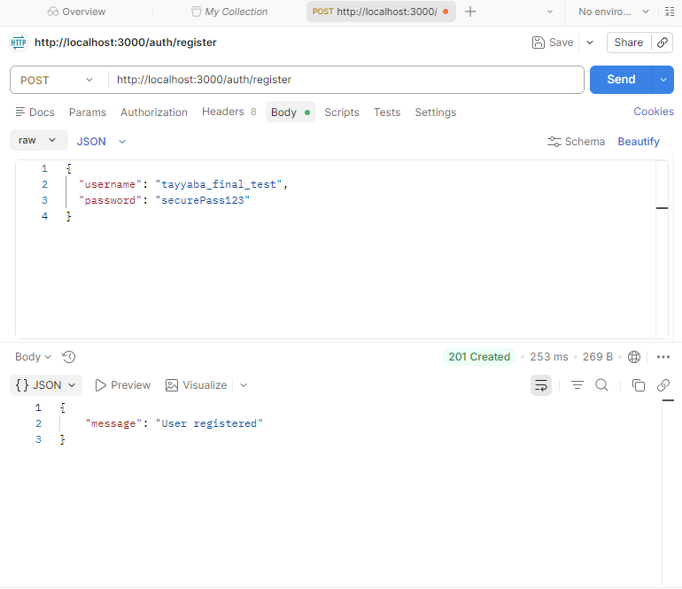

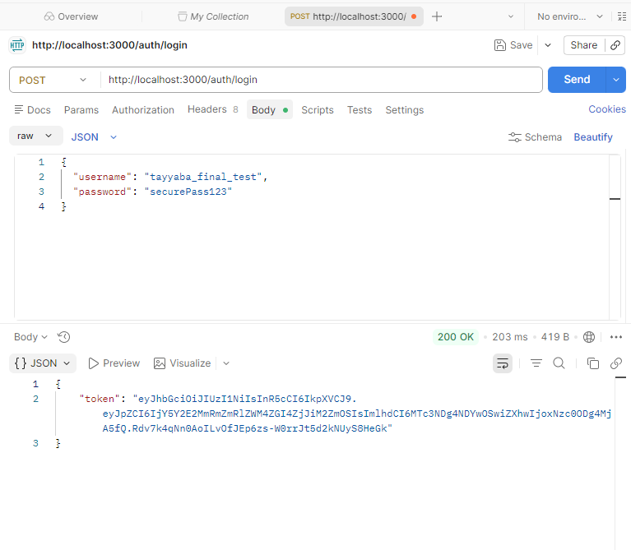
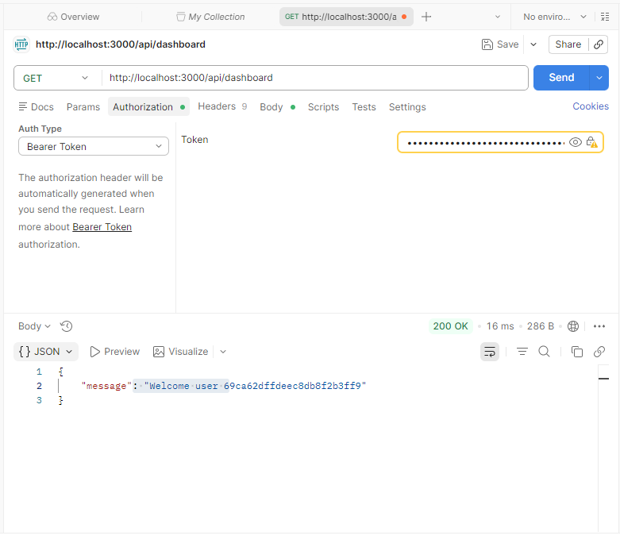

Conclusion :
"In this lab, I successfully implemented a secure Authentication and Authorization system using Node.js, Express, and MongoDB. The core focus was on understanding JWT (JSON Web Tokens) to protect routes and manage user sessions.
Key takeaways include:
- Security: Learned how to hash passwords using bcrypt before storing them in the database to ensure user privacy.
- Middleware: Understood the role of custom middleware in intercepting requests to verify tokens before granting access to protected resources.
- API Testing: Gained proficiency in using Postman to simulate client-side requests, handle various HTTP methods (POST, GET), and manage Authorization headers.
- Separation of Concerns: Implemented a clean project structure by separating models, routes, and middleware, which is essential for scalable web applications."

